**Assignment**

1. **Git branching strategy**

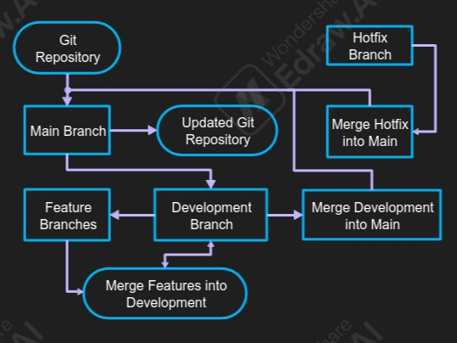

**Flow and Interactions**

* **Main Workflow:**
  + Code flows downstream from main to develop to ensure all hotfixes are applied to the development branch.
  + Changes from develop are periodically merged into main during a release.
* **Feature Development Workflow:**
  + New branches are created from develop for individual features.
  + Developers work on features in isolation.
  + Completed features are merged into develop via a pull request, followed by code reviews.
* **Hotfix Workflow:**
  + When a critical issue arises, a hotfix branch is created directly from main.
  + After fixing, the hotfix is merged into main and develop to keep both branches synchronized.

1. **Language table and their dependencies**

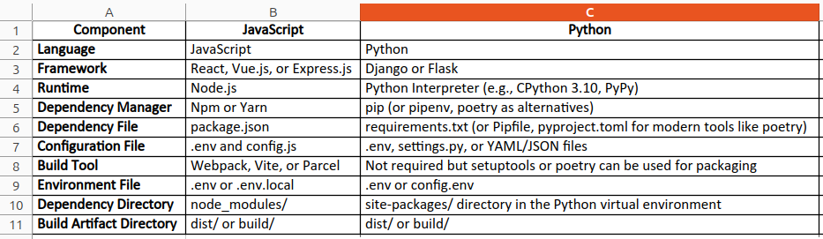

1. **Kickstart application build and deploy**

* Install gh to fork and clone remote repository --> sudo apt install gh
* Complete the authentication for gh to fetch your repo --> gh auth login --web
* Clone the repo in your working dir --> gh repo fork https://github.com/Shoaib720/kickstart-angular.git –clone --> (if already done forking directly clone that forked repo in your local working dir)
* After cloning change permission --> chmod 775 kickstart-angular/ -R
* Install npm, node and angular-cli to run and deploy the app (use nvm to install specific node version)
  + sudo apt install npm
  + curl -o- https://raw.githubusercontent.com/nvm-sh/nvm/v0.39.3/install.sh | bash --> (after it gets finished restart the terminal)
  + nvm list --> (will show all available version select v14)
  + nvm install 14 (if nothing is found directly install 14)
  + npm install -g @angular/cli
  + npm install --> (to install all required packages as mentioned in package.json)
  + npm audit fix --> (it will fix some compatible issue while installing packages)
* Run the app --> npm start --> (Screenshot below)

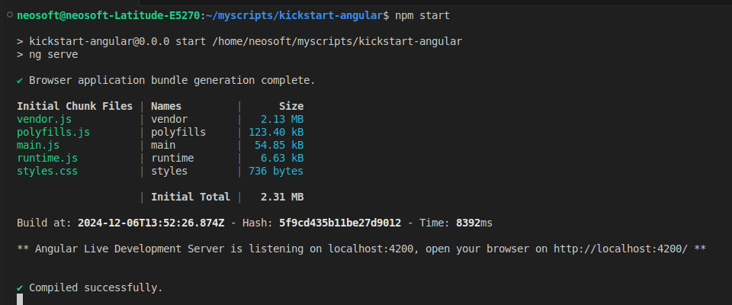

* Click on the url generated and the app opens in the browser

